КЫРГЫЗСКИЙ ТЕХНИЧЕСКИЙ УНИВЕРСИТЕТ им. И. Раззакова

ФАКУЛЬТЕТ ИНФОРМАЦИОННЫХ ТЕХНОЛОГИЙ

Кафедра «ПРОГРАММНОЕ ОБЕСПЕЧЕНИЕ КОМПЬЮТЕРНЫХ

СИСТЕМ»

Дисциплина

Методы оптимизации

Отчет

по практической работе №4

«Newton Method»

Выполнил: студент группы ПИ-1-16

Абакиров Нурсултан

Проверил:

кандидат технических наук, профессор

Тен Иосиф Григорьевич

# Раздел №1 Наименование работы

Найти корень произвольного нелинейного уравнения f(x) с заданной допустимой погрешностью Tolerance не более величины 1E–28 методом касательных (Newton Method). Нелинейная функция f(x) имеет произвольный аналитический вид, составленный из математических функций (полиномов различных степеней, тригонометрических – sin(x), cos(x), exp(x), ln(x), log(x) и. т. д.), которая имеет математический смысл, и для которой существует хотя бы одно решение задачи.

# Раздел №2 Спецификация метода

|  |  |
| --- | --- |
| Mathematical Description of Algorithm of the Newton’s Method | Computational Description of Algorithm of the Newton’s Method |
| $$x^{k+1}=x^{k}-\frac{f^{'}\left(x^{k}\right)}{f^{''}\left(x^{k}\right)} for all k=0, 1, …;$$ | **INPUT** {X0; Epsilon; Delta; R; Max}  **Body of algorithm**  Cond: = 0; /* Condition for loop termination */  FX0: = f(X0); /* Objective function at given point */  DFX0: = f ‘(X0); /* First derivative of the objective function at given point */  DDFX0: = f ‘’(X0); /* Second derivative of the objective function at given point */  |DO FOR K: = 1 TO Max UNTIL Cond≠0;  | DDFX0: = f ‘’(X0); /* Second derivative of the objective function at given point */  | |IF abs( DDFX0)<=Epsilon THEN  | | Cond:=1; QND: =0; /* QND stands for Quotient is Numerator/Denominator */  | | ELSE DP:= DFX0/DDFX0; /* Quotient – частное = numerator/denominator */  | |IF K=1 THEN DP0:= DP;  | |ENDIF  | |IF SIGN(DP0)=SIGN(DP) /* Handle an auto-oscillation */  | | THEN X1:= X0 – DP; /* If an Oscillation is absent */  | | ELSE X1:= X0 – DP/R; /* If an Oscillation is present */  | |ENDIF  | | DP0:=DP;  | | FX1:=f(X1); /* New objective function value */  | | DFX1:=f ‘(X1); /* First derivative of objective function value */  | | RelError:= 2*ABS(DP)/(ABS(X1) + Epsilon); /* Relative error */  | | |IF RelError < Delta THEN /* Check of convergence of sequence */  | | | |If Cond ≠ 1 THEN Cond:= 2;  | | | |ENDIF  | | |ENDIF  | | X0:= X1; DFX0:= DFX1; /* Update values */  | |ENDIF  |ENDDO  **OUTPUT**  PRINT ‘The optimum solution x* equal’ X1  PRINT ‘The optimum solution was found with the desired tolerance’ Epsilon  PRINT ‘The minimum of objective function f(x*) is’ FF1  PRINT ‘The value of first derivative f ’(x) is‘ DFX1  /* *Report about searching process state is given from program */*  IF Cond = 0 THEN  PRINT “The maximum number of iterations was exceeded”  IF Cond = 1 THEN  PRINT “Division by zero was encountered”  IF Cond = 2 THEN  PRINT “The solution was found with the desired tolerance” |
| x0 – Initial approximation;  ε – Tolerance;  fk = f(xk) – objective function at point xk. | X0 – Initial approximation;  Epsilon – Tolerance;  Delta – Parameter to check convergence of sequence are generated under study method by comparison the relative error value;  R – Optional generic parameter to squeeze seeking area to handle auto-oscillation;  Max – Limit number of iterations. |

# Раздел №3 Стадии проектирования системы

1. Разработка блок-схемы Newton Method find minimum:



1. Разработка пользовательского интерфейса.

Форма для взаимодействия пользователя с программой представлена ниже:



# Раздел №4 Документирования этапов проектирования интерфейсной формы системы



|  |  |  |  |
| --- | --- | --- | --- |
| **Number of control** | **Control** | **Property** | **Setting** |
| 1 | Label | Appearance (Text) | Function f(x): |
| Design (Name) | Label1 |
| 2 | Label | Appearance (Text) | x0 |
| Design (Name) | Label2 |
| 3 | Label | Appearance (Text) | Limit of Time(in mil sec): |
| Design (Name) | Label3 |
| 4 | Label | Appearance (Text) | Delta |
| Design (Name) | Label4 |
| 5 | Label | Appearance (Text) | Tolerance: |
| Design (Name) | Label5 |
| 6 | Label | Appearance (Text) | Limit of iterations: |
| Design (Name) | Label6 |
| 7 | Label | Appearance (Text) | X1: |
| Design (Name) | Label7 |
| 8 | Label | Appearance (Text) | f(X1): |
| Design (Name) | Label8 |
| 9 | Label | Appearance (Text) | Number Of Iterations: |
| Design (Name) | Label9 |
| 10 | Label | Appearance (Text) | Elapsed time (in mil seconds): |
| Design (Name) | Label10 |
| 11 | Label | Appearance (Text) | RelError |
| Design (Name) | Label11 |
| 12 | Label | Appearance (Text) | “” |
| Design (Name) | result |
| 13 | Label | Appearance (Text) | f2(X1): |
| Design (Name) | Label12 |
| 14 | Textbox | Appearance (Text) | x^2-4*sin(x) |
| Design (Name) | fx |
| 15 | Textbox | Appearance (Text) | 1 |
| Design (Name) | a |
| 16 | Textbox | Appearance (Text) | 3 |
| Design (Name) | B |
| 17 | Textbox | Appearance (Text) | 10000 |
| Design (Name) | time |
| 18 | Textbox | Appearance (Text) | 1E-14 |
| Design (Name) | Tolerance |
| 19 | Textbox | Appearance (Text) | 100 |
| Design (Name) | Limit |
| 20 | Textbox | Appearance (Text) | extremum of function |
| Behavior (ReadOnly) | True |
| Design (Name) | x1 |
| 21 | Textbox | Appearance (Text) | F(x1) |
| Behavior (ReadOnly) | True |
| Design (Name) | yf1 |
| 22 | Textbox | Appearance (Text) | F2(x1) |
| Behavior (ReadOnly) | True |
| Design (Name) | yF2 |
| 23 | Textbox | Appearance (Text) | amount of iterations |
| Behavior (ReadOnly) | True |
| Design (Name) | iter |
| 24 | Textbox | Appearance (Text) | elapsed time |
| Behavior (ReadOnly) | True |
| Design (Name) | time |
| 25 | Textbox | Appearance (Text) | RelError |
| Behavior (ReadOnly) | True |
| Design (Name) | relerror |
| 28 | Button | Appearance(Text) | Run Newton Method |
| Design(Name) | button1 |
| 29 | Button | Appearance(Text) | clear |
| Design(Name) | button2 |
| 31 | ProgressBar | Design(Name) | progressBar1 |

# Раздел №5 Стадии конструирования ПО

Код программы на SWIFT, ассоциированный с интерфейсной формой и реализует логику Golden Section по поиску корня нелинейного уравнения “ViewController.swift” 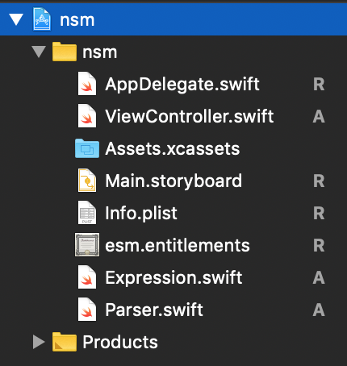

*//*

*// ViewController.swift*

*// esm*

*//*

*// Created by user on 12/8/18.*

*// Copyright © 2018 user. All rights reserved.*

*//*

**import** Cocoa

**class** ViewController: NSViewController {

**@IBOutlet** **weak** **var** functionsInput: NSComboBoxCell!

**@IBOutlet** **weak** **var** fd1Input: NSComboBox!

**@IBOutlet** **weak** **var** fd2Input: NSComboBox!

**@IBOutlet** **weak** **var** x0Input: NSTextField!

**@IBOutlet** **weak** **var** deltaInput: NSTextField!

**@IBOutlet** **weak** **var** rInput: NSTextField!

**@IBOutlet** **weak** **var** toleranceInput: NSTextField!

**@IBOutlet** **weak** **var** kMaxInput: NSTextField!

**@IBOutlet** **weak** **var** tMaxInput: NSTextField!

**@IBOutlet** **weak** **var** xOutput: NSTextField!

**@IBOutlet** **weak** **var** fOutput: NSTextField!

**@IBOutlet** **weak** **var** relOutput: NSTextField!

**@IBOutlet** **weak** **var** fd1Output: NSTextField!

**@IBOutlet** **weak** **var** fd2Output: NSTextField!

**@IBOutlet** **weak** **var** kOutput: NSTextField!

**@IBOutlet** **weak** **var** elapsedTimeOutput: NSTextField!

**@IBOutlet** **weak** **var** progressBar: NSProgressIndicator!

**@IBOutlet** **weak** **var** messageOutput: NSTextField!

**override** **func** viewDidLoad() {

**super**.viewDidLoad()

*// Do any additional setup after loading the view.*

}

**override** **var** representedObject: **Any**? {

**didSet** {

*// Update the view, if already loaded.*

}

}

**func** sign(x: Double) -> Int {

**if** x < 0 {

**return** -1

}

**else** **if** x > 0 {

**return** 1

}

**else** {

**return** 0

}

}

**@IBAction** **func** runBtnClicked(**_** sender: **Any**) {

**self**.clear()

**if** !**self**.isValid() {

**return**

}

**let** f = Parser(expression: functionsInput.stringValue)

**let** fd1 = Parser(expression: fd1Input.stringValue)

**let** fd2 = Parser(expression: fd2Input.stringValue)

**let** delta = deltaInput.doubleValue

**var** x0 = x0Input.doubleValue

**let** r = rInput.doubleValue

**let** tol: Double = toleranceInput.doubleValue

**var** kMax: Int = kMaxInput.integerValue

**let** tMax: Double = tMaxInput.doubleValue

**var** fx0: Double

**var** dfx0: Double

**var** ddfx0: Double

**var** qnd: Double

**var** dp0: Double = 0

**var** dp: Double = 0

**var** relEr: Double

**var** x1: Double

**let** startTime = Date()

**var** endTime = NSDate()

**var** isTimeReached = **false**

**var** k: Int = 0

**var** cond: Int = 0

progressBar.doubleValue = 0.0

**repeat** {

k += 1

progressBar.doubleValue = Double(k * 100 / kMax)

fx0 = f.run(x: x0)

dfx0 = fd1.run(x: x0)

ddfx0 = fd2.run(x: x0)

**if** abs(ddfx0) <= tol {

qnd = 0

cond = 1

} **else** {

dp = dfx0 / ddfx0

}

**if** k == 1 {

dp0 = dp

}

**if** sign(x: dp0) == sign(x: dp) {

x1 = x0 - dp

} **else** {

x1 = x0 - dp / r

}

dp0 = dp

relEr = 2 * abs(dp) / (abs(x1) + tol)

**if** relEr <= delta {

**if** cond != 1 {

cond = 2

}

}

x0 = x1

endTime = NSDate()

**if** k == kMax {

**if** **self**.dialogOKCancel(question: "Continue Search?", text: "Solution was not found in given limit of iterations, add \(kMax) more iterations") {

kMax += kMax

kMaxInput.stringValue = String(kMax)

} **else** {

messageOutput.stringValue = "Attention: It isn't possible to find a solution\nwith a given Number Of Iterations = \(kMax)"

}

}

**if** endTime.timeIntervalSince(startTime) >= tMax {

isTimeReached = **true**

messageOutput.stringValue = "Not possible to find solution for given \ntime limit \(tMax)"

}

} **while** k < kMax && !isTimeReached && cond == 0

**if** cond == 1 {

messageOutput.stringValue = "The optimal solution is not found. Met division by zero"

}

**else** **if** cond == 2 {

**let** lfx0 = f.run(x: x0 + tol)

**let** lfx1 = f.run(x: x0 - tol)

print(fx0)

print(lfx0)

print(lfx1)

**if** lfx0 > fx0 && lfx1 > fx0 {

messageOutput.stringValue = "Found minimum of function"

}

**else** **if** lfx0 < fx0 && lfx1 < fx0 {

messageOutput.stringValue = "Found maximum of function"

}

**else** {

messageOutput.stringValue = "Found kink point of function"

}

}

*// if k == 1 && found {*

*// messageOutput.stringValue = "Can't find an extremum or X0 placed in \nthe right-of-solution X*"*

*// self.alertModal(messageText: "Try X0 be lefter and closer to X*", informativeText: "Found not best fit X*")*

*// }*

progressBar.doubleValue = 100

xOutput.doubleValue = x0

fOutput.doubleValue = fx0

relOutput.doubleValue = relEr

fd1Output.doubleValue = dfx0

fd2Output.doubleValue = ddfx0

kOutput.stringValue = String(k)

elapsedTimeOutput.doubleValue = endTime.timeIntervalSince(startTime)

}

**@IBAction** **func** clearBntClicked(**_** sender: **Any**) {

**self**.clear()

}

**func** clear() {

progressBar.doubleValue = 0

xOutput.stringValue = ""

fOutput.stringValue = ""

relOutput.stringValue = ""

fd1Output.stringValue = ""

fd2Output.stringValue = ""

kOutput.stringValue = ""

elapsedTimeOutput.stringValue = ""

messageOutput.stringValue = ""

}

**func** setInvalidInput() {

**self**.alertModal(messageText: "invalid input", informativeText: "")

messageOutput.stringValue = "invalid input"

}

**func** isValid() -> Bool {

**for** raw **in** [functionsInput.stringValue, fd1Input.stringValue, fd2Input.stringValue] {

**let** f = Parser(expression: raw)

**do** {

**_** = **try** f.check_run(x: 1)

} **catch** {

**self**.setInvalidInput()

**return** **false**

}

}

**for** el **in** [x0Input, deltaInput, rInput, toleranceInput, kMaxInput, tMaxInput] {

**if** Double(el!.stringValue) == **nil** {

**self**.setInvalidInput()

**return** **false**

}

}

**return** **true**

}

**func** alertModal(messageText: String, informativeText: String) {

**let** alert = NSAlert()

alert.messageText = messageText

alert.informativeText = informativeText

alert.alertStyle = .warning

alert.addButton(withTitle: NSLocalizedString("OK", comment: "OK"))

alert.runModal()

}

**func** dialogOKCancel(question: String, text: String) -> Bool {

**let** alert = NSAlert()

alert.messageText = question

alert.informativeText = text

alert.alertStyle = .warning

alert.addButton(withTitle: "OK")

alert.addButton(withTitle: "Cancel")

**return** alert.runModal() == .alertFirstButtonReturn

}

}

5.3: Подключение библиотечной программы “ Expression ” к программному проекту для выполнения функции парсинга

Шаг №1: Скачать с сайта https://github.com/nicklockwood/Expression/tree/master/Sources

файл парсера [Expression.swift](https://github.com/nicklockwood/Expression/blob/master/Sources/Expression.swift):

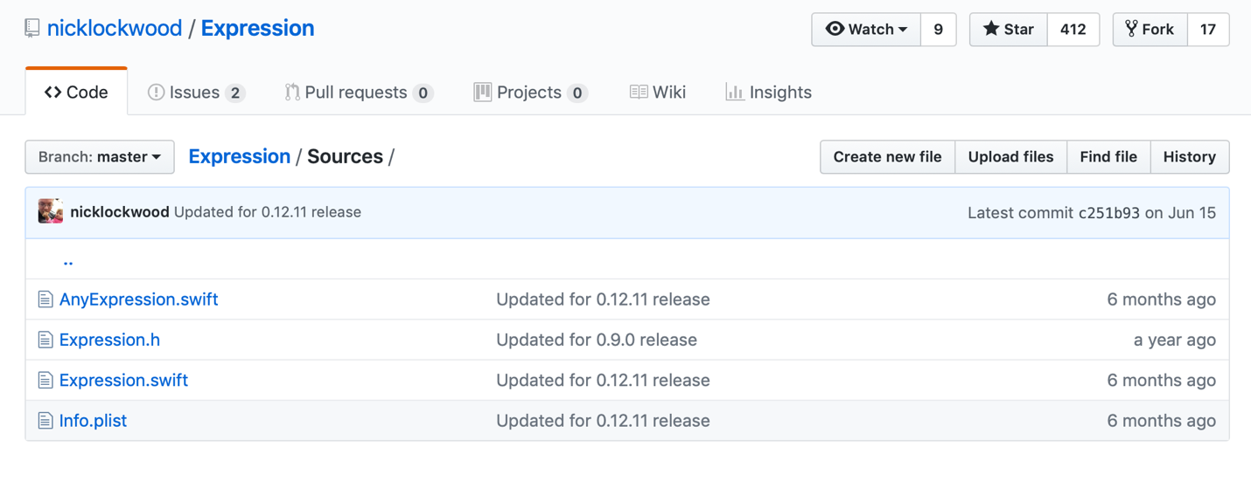

Шаг №2: Вставить скаченный файл в папку проекта:

Шаг №3: Так как парсер не предоставляет полный спектр математических функций, дописываем файл Parser.swift

**import** Foundation

**class** Parser {

**private** **var** expression: Expression

**private** **var** x: Double

**init**(expression: String) {

**self**.x = 0

**self**.expression = Expression("1 + 1")

**self**.expression = Expression(expression, symbols: [

.variable("x"): { **_** **in** **self**.x},

.function("exp", arity: 1): {args **in** exp(args[0])},

.function("log", arity: 1): {args **in** log(args[0])},

])

}

**public** **func** run(x: Double) -> Double {

**self**.x = x

**do** {

**return** **try** **self**.expression.evaluate()

} **catch** {

fatalError()

}

}

}

# Раздел №6 Тестирование

1. Тест №1 функция: x^2-4*sin(x), проверка стандартных функций 
2. Тест №2. Проверка на вывод ошибки о недостаточном количестве итераций



1. Тест№3. Проверка на вывод ошибки о недостаточном количестве времени



1. Тест№4. Проверка правильности целевой функции



1. Тест №5 функция: x^3-5*x^2+x+5, проверка стандартных функций (min)



1. Тест №1 функция: x^3-5*x^2+x+5, проверка стандартных функций (max)

